**Imogen’s hints**

Because they are creating large sets, humans usually lean on patterns. Spotting these can help work out if an account is a bot.

Avatars and strip headers come in sets, examples and themes

* Impressionist paintings strip header / avatar
* Symmetrical patterns in strip header

They will hit on a football club, to make it look like they are supporters. So they add, for example, spurs hashtags or COYS, to blend in and also recruit. Usually teams with sectarian divisions.

We all know that not having an avatar is a clue that you are probably a bot.

If you don’t choose an id, you get a default – a big clue that it is a bot.

Emojis – union jacks, stars and stripes, star, cross mark, trident

Sometimes use a royal family Twitter avatar and strip e.g. from [**@**KensingtonRoyal](https://twitter.com/KensingtonRoyal)

These names just naturally attract people.

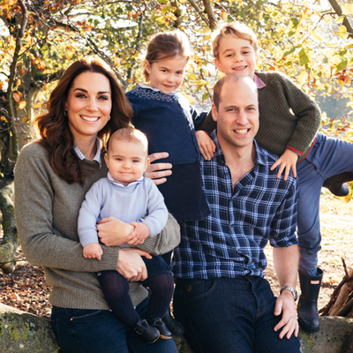

Commonly use “We the people” as a strip header.

